Sustaining Well-being
As leaders in this movement, we are often fighting on multiple fronts—combating climate change, protecting endangered species, and advocating for policies that sustain our community’s health. Leading in the face of such significant challenges can quickly lead to stress, burnout, and exhaustion. So, how can we nourish our resilience and safeguard our well-being as we continue to lead the charge for a more sustainable future? Let’s walk through some of the practices that will fortify us for the road ahead.

What Is Resilience?
- Resilience is how you replenish and thrive, not how you endure
- Resilience is how you bounce forward, not how you bounce back
- Resilience is what you need to keep showing up at your best in your life: physically, mentally and spiritually well and fulfilled

Resilience Myths
There are some prevalent myths that exist about resilience, including:
- Resilience is something you’re born with
- Resilience is never giving up
- Resilience is doing everything on your own
- Resilience is about powering through
- Resilience is about managing all negative emotions

The Five Key Elements of Resilience
To build true resilience, it’s essential to develop practices that support all the elements of well-being. These include:

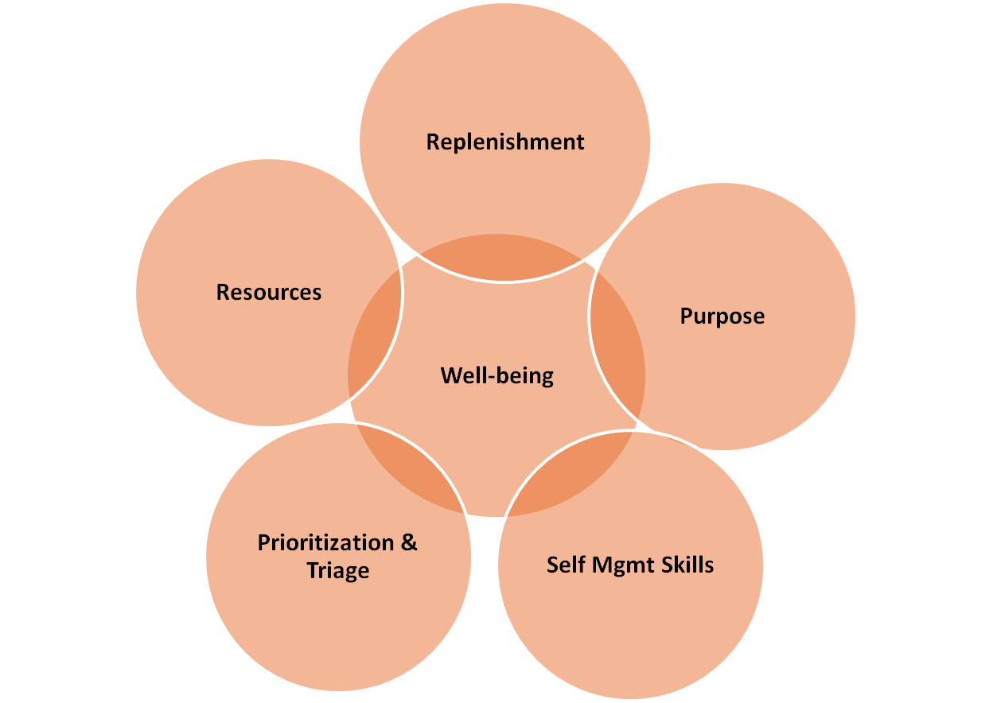
- Replenishment: You can’t lead effectively if you’re running on empty. Without replenishing your energies, even the most well-intentioned efforts will falter. Resilience is about knowing when to pause, rest, and recharge.
- Self Management Skills: Building resilience requires developing practical skills that help you navigate life’s challenges. By cultivating these skills, you give yourself the tools to stay centered, even when things get chaotic.
- Purpose: Resilience is supported by a sense of direction. Leaders need to constantly reconnect with their “why”—the deeper mission behind their work—to stay grounded and motivated.
- Prioritization and Triage: In a world full of demands, knowing what truly matters is critical. Prioritizing your goals and triaging out distractions is essential to maintaining focus.
- Resources: Resilience isn’t built in isolation. Leaders need access to resources—whether they are physical, emotional, or social. With the right resources, you can weather storms and keep moving forward.


Building Your Life’s House
To better understand how resilience works, imagine that your life is like a house.

- The roof of your house represents your work—the protective layer that provides security and stability. It’s where you derive purpose and meaning, but also where much of your stress often originates.

- The main structure of your house represents your personal life—relationships, hobbies, rest, and other activities that bring joy and fulfillment. It’s the heart of your existence and what sustains you day-to-day.

- Finally, the foundation of the house is your self-care—your physical, emotional, and mental health. This is the bedrock of resilience, the solid ground that keeps your house steady and secure. Without a strong foundation, nothing else stands.

The Resilience 5 R’s: A Framework for Thriving
To help you cultivate resilience in a way that aligns with your leadership goals, consider adopting the "5 R’s" of resilience:

Reassess, Reduce, Reframe, Recharge, and Realign

- Reassess: Step back and take a broad view of your life and leadership. How do your days feel? What are the biggest sources of stress? Are you spending your time on what truly matters? What’s working and what isn’t?

- Reduce: Stress comes from both external pressures (work demands, financial stress) and internal reactions (self-imposed expectations, fears, and limiting beliefs). Where can you reduce your chronic stress load by saying no or delegating?

- Reframe: Often, stress and burnout are fueled by unhelpful thoughts, attitudes, and expectations. Reframing involves looking at situations through a different lens, challenging negative beliefs, and setting more realistic expectations. How can you change the way you are perceiving a challenge that is causing you stress?

- Recharge: This is about regularly replenishing your energy. Where can you begin to prioritize your physical, emotional, and mental well-being?

- Realign: The final step is realignment: adjusting your actions to reflect your priorities and values. What will you start, stop, and continue doing in service of your well-being?

