4 Steps to Address Performance Challenges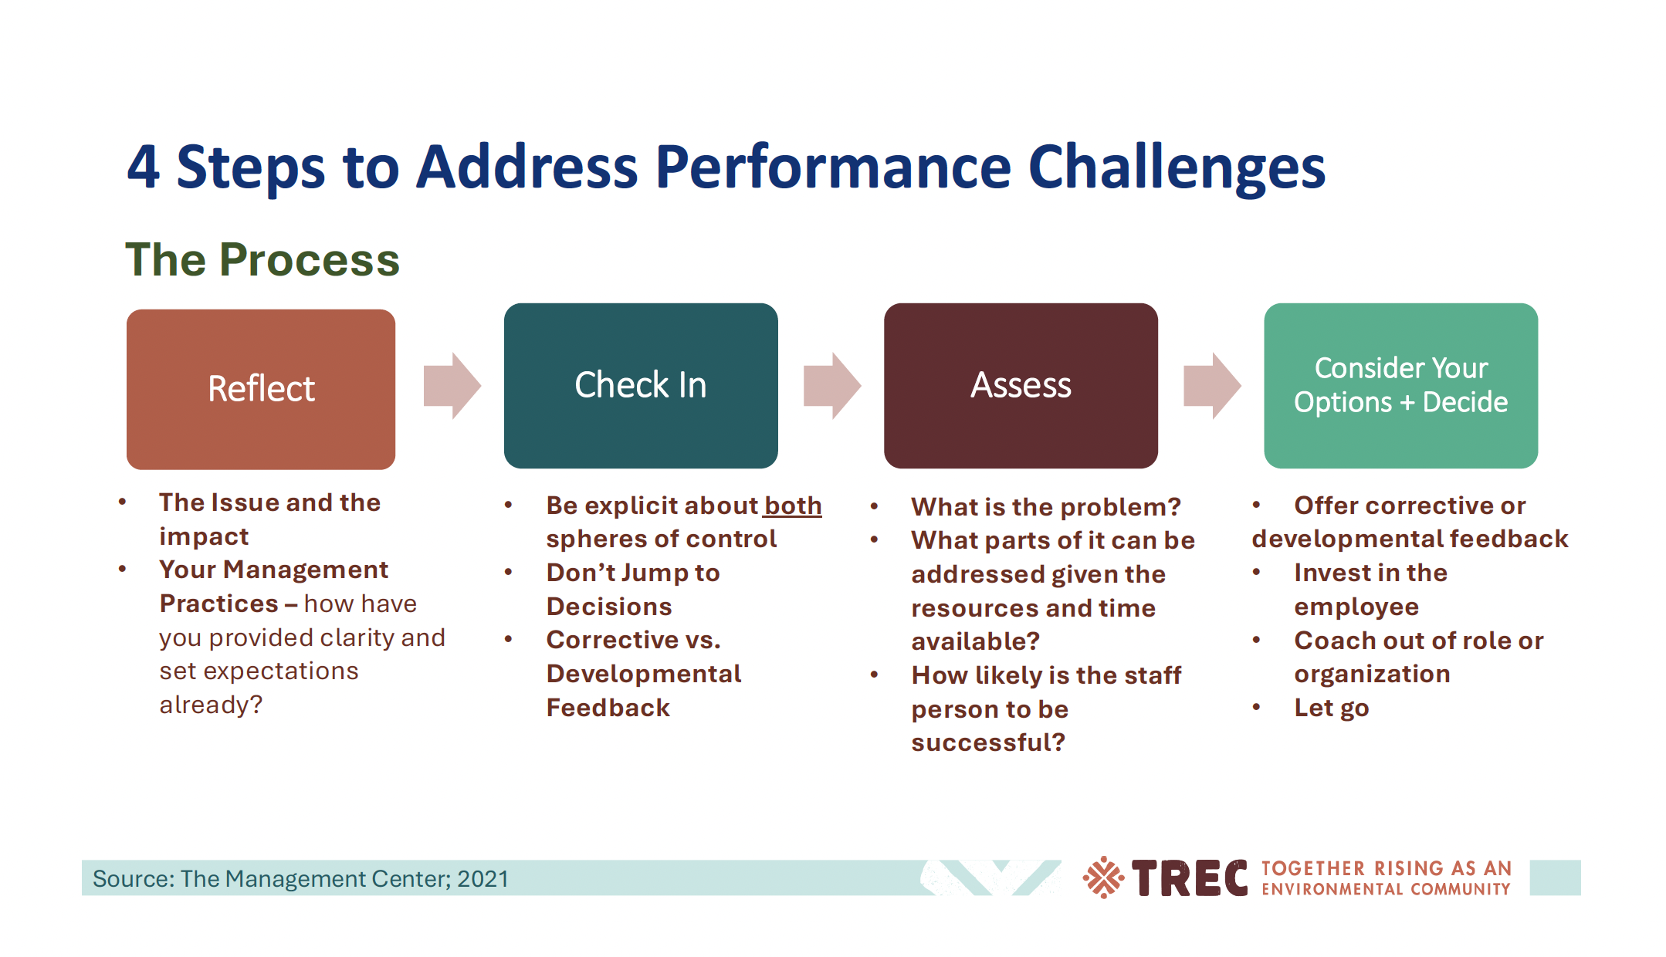Fillable Worksheet for Supervisors

1. Reflect
• Describe the issue and its impact:

• How have you provided clarity and expectations?

2. Check In
• What is within your control? What is within the employee’s control?

• Have you avoided jumping to conclusions? Notes:

• Is this corrective or developmental feedback?
☐ Corrective ☐ Developmental

3. Assess
• What is the core problem?

• What parts can be addressed with current resources?

• Likelihood of success (1–5): ☐1 ☐2 ☐3 ☐4 ☐5

4. Consider Options + Decide
• Selected approach (check all that apply):
☐ Corrective feedback
☐ Development plan
☐ Invest in training/coaching
☐ Coach out of role/organization
☐ Separation/Let go
• Action plan and timeline:

Supervisor Reflection
What support do you need to follow through?

